Code

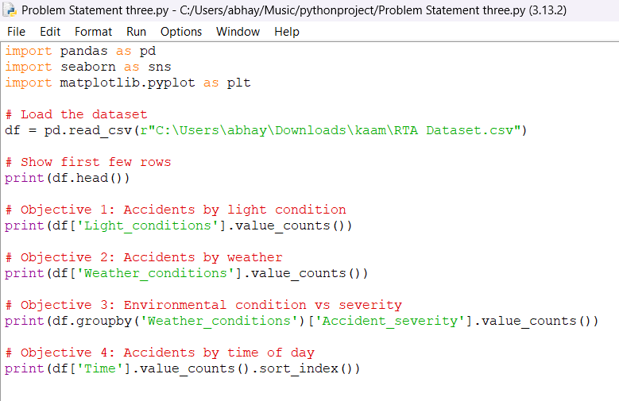

->Problem Statement 3: Environmental and Light Conditions

import pandas as pd

import seaborn as sns

import matplotlib.pyplot as plt

# Load the dataset

df = pd.read_csv(r"C:\Users\abhay\Downloads\kaam\RTA Dataset.csv")

# Show first few rows

print(df.head())

# Objective 1: Accidents by light condition

print(df['Light_conditions'].value_counts())

# Objective 2: Accidents by weather

print(df['Weather_conditions'].value_counts())

# Objective 3: Environmental condition vs severity

print(df.groupby('Weather_conditions')['Accident_severity'].value_counts())

# Objective 4: Accidents by time of day

print(df['Time'].value_counts().sort_index())

